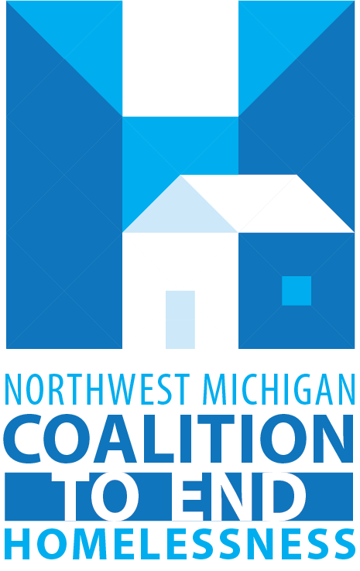

MI-512- Greater Grand Traverse Area Continuum of Care/
Northwest Michigan Coalition to End Homelessness
HUD SPECIAL NOFO Timeline-Rural Set Aside

Contact information
Northwest Michigan Coalition to End Homelessness:
- Ashley Halladay-Schmandt, (Director) ashley@endhomelessnessnmi.org 231.499.1019
- Jayce Ashwill, (NWCEH System Administrator) jayce@endhomelessnessnmi.org

Resources
- NWCEH Website: www.endhomelessnessnmi.org
- HUD CoC Program Competition Website: https://www.hud.gov/program_offices/comm_planning/coc/specialCoCNOFO

ALL DATES ARE SUBJECT TO CHANGE
To be determined dates highlighted in gold

ACTION | ENTITY RESPONSIBLE | TIMEFRAME/DUE DATE
Release of the Special NOFO for Unsheltered Homelessness and Rural Set Aside | HUD | June 22, 2022
Local Competition Opens | NWCEH | August 23, 2022
Local Application for Rural Set Aside New Projects is released | NWCEH Director | August 23, 2022
Local Application for Rural Set Aside New Projects are DUE | Project Applicants | September 6th, 2022
Review and scoring of all Rural Set Aside Applications | NWCEH Director and NWCEH Steering Committee | Scored by Sept. 12th, 2022
Project applicants are provided their scores | NWCEH Director | September 12th, 2022
Steering Committee meets to review all applications and scoring | NWCEH Steering Committee | September 19th, 2022
Projects are due in e-snaps | Project Applicants | October 3rd, 2022
Priority Ranking Released | NWCEH Director | October 5th, 2022
Draft of Plan released | NWCEH Director | October 10th, 2022
Draft of Collaborative Application released | NWCEH Director | October 5th^{th}, 2022
Entire Application submitted in esnaps | NWCEH Director | October 17th, 2022

